TEST
PRODUCT
QUALIFICATION
REPORT

TITLE:
LT3795 Test Site Transfer from Analog Devices Singapore to
Analog Devices General Trias Philippines

PCN Number:
PCN 20_0231

REVISION:
A

DATE:
September, 2020

CONTENTS:

Summary
Table 1 - LT3795 Test Details
Table 2 - Qualification Activities and Acceptance Criteria
Table 3 - Correlation Device Run Results
Table 4 - Product Site Transfer Correlation
Table 5 - Manufacturing Validation Lot Run
Table 6 - GR&R Result

PROJECT BACKGROUND:
The LT3795 is currently undergoing production testing at the Analog Devices Singapore (ADSG). It was a strategic decision from business standpoint to qualify Analog Devices General Trias (ADGT) which will soon serve as production site after ADSG closure. ADGT is situated in Gateway Business Park, General Trias, Cavite, Philippines. The manufacturing facility have 1 Million square foot building in a 15 hectares land area. It houses ~900 Testers and ~1000 handlers with 4,850 total employees which includes 1,000 engineers composed of Test, Product, Failure Analysis, Reliability, Design and Layout Engineers. ADGT passed and qualified on different certifications such as: IATF 16949, ISO 9001, ISO 14001, OHSAS 18001, ANSI ESD S20.20, IEC 61340-5-1. The plant produces 375 Million test output per quarter and caters different testing capability such as Package Testing, WLCSP Testing and Die Preparation, Wafer Trim and Probe and Mil-Aerospace Assembly & Test. In terms of product test capability, ADGT caters testing for Automotive, RF, Power, MEMS, µIsolators, Mixed Signal High Speed Precision Converters and Mil-Aerospace products. After qualification and replication of necessary test capability, ADGT will serve as the primary test site facility to serve future demands.

SUMMARY:
The LT3795 is a DC/DC controller designed to regulate a constant-current or constant-voltage and is ideal for driving LEDs. It drives a low side external N-channel power MOSFET from an internal regulated 7.7V supply. The fixed frequency and current mode architecture result in stable operation over a wide range of supply and output voltages. Spread spectrum frequency modulation (SSFM) can be activated for improved electromagnetic compatibility (EMC) performance. The ground referred voltage FB pin serves as the input for several LED protection features, and also allows the converter to operate as a constant-voltage source. The maximum output current is set by an external resistor, and the output current amplifier has a rail-to-rail common mode range. The LT3795 also includes a separate input current sensing amplifier that is used to limit input current. The TG pin inverts and level shifts the PWM signal to drive the gate of the external PMOS. The PWM input provides LED dimming ratios of up to 3000:1, and the CTRL inputs provide additional analog dimming capability.

TEST AND PRODUCT INFORMATION:

Device: LT3795
Package: 28-LEAD PLASTIC TSSOP
Leads: 28 LEADS
FG Partname: LT3795IFE#TRPBF
Tester Platform: ETS
Handler: RASCO1000

The LT3795 is planned to be tested in Analog Devices General Trias (ADGT) using the following as shown in the Table 1 below:
Table 1: LT3795 Test Details
Parameters | ADSG | ADGT | Remarks
Tester Platform | ETS-364B | ETS-364B | No change
Handler | RASCO1000 | RASCO1000 | No Change
Test Flow | FT_Room 100%-QAR-QAC-QAC MONITOR-QAH | FT_Room 100%-QAR-QAC-QAC MONITOR-QAH | No Change
Contactor | JT-FE28-5394 | LTC-00247 | No change  (Apply ADI Hardware naming standard)
Test Board | LT3795 Performance Board | L-10402 | No change  (Apply ADI Hardware naming standard)
Test Program | LT3795_FT_06 | V16540P02 | No change  (Apply ADI Program Filename Standard)

There is no change to the form, fit and function of the product.
This report documents the successful completion of the product test transfer requirements of LT3795 at ADGT.

DESCRIPTION AND TEST RESULTS:
Below tables provide description of the qualification tests conducted and corresponding test results for LT3795. All the units have undergone electrical tests on both the sending and receiving sites on the same test platform. Any device that will not meet the electrical qualification requirements will mean failure of the qualification and require solid corrective actions and a repeat of the qualification process. Qualification activities performed, and acceptance criteria is shown on Table 2:

Table 2: Qualification Activities and Acceptance Criteria
Qualification Activity | Sample Quantity | Accept Criteria
Correlation device run | 5 correlation device units | *100% Passing correlation devices
Correlation Lot Run | Minimum of 300 known Bin1 units tested in full product test flow (ALL temperature passes). Test lot in Sending site (ADSG) and Receiving site (ADGT). | *CpK≥1.67  * For tightened limits, Mean Shift Criteria and sigma-spread criteria to apply  * Mean Shift Criteria  (ABS (SS_mean - RS_Mean) / Limit Range ) x 100 ≤ 5%  * Sigma-spread criteria  * (RS_Sigma / SS_Sigma ) ≤ 1.3
Validation Lot Run | Minimum of 1,000 fresh units in full product test flow (ALL temperature passes) | Lot yield comparison between  sending site vs. receiving site should match
Untrimmed/Fresh unit verification using QA program | 5 Fresh (Untrimmed) unit tested in QA Program. | QC program must detect untrimmed or fresh parts
GR&R | 10 Bin 1 units tested on 1 board and 3 testers | R&R % =<10%
- SS = Sending Site
- RS = Receiving Site

To validate full set-up functionality such as hardware, software, test paraphernalia and tester platform, 5 correlation devices of LT3795 were tested both in ADSG and ADGT. Data between sites were analyzed and summarized in Table 3.
Table 3: Correlation Device Run result
Generic | Package | No. of correlation device | ALL correlation devices passed?
LT3796 | 28-LEAD PLASTIC TSSOP (RB) | 5 units | YES

The LT3795 was qualified by testing a correlation lot with minimum 300 units both in ADSG and ADGT. This is to capture variation in hardware, tester and set-up condition thru mean shift and sigma spread. This is to ensure the parameter measurement are still within the accepted range of variations. Data between sites were analyzed and summarized in Table 4.

Table 4: Product Site Transfer Correlation
Temperature | Generic | Package | Lot Number | Lot Size | Sending Site | Receiving Site | Total No. of Correlation Parameters | Result
Ambient | LT3795 | 28-LEAD PLASTIC TSSOP | 993984.1 | 399 | ADSG | ADGT | 55 | ALL PASSED
Hot | LT3795 | 28-LEAD PLASTIC TSSOP | 993984.1 | 399 | ADSG | ADGT | 55 | ALL PASSED
Cold | LT3795 | 28-LEAD PLASTIC TSSOP | 993984.1 | 399 | ADSG | ADGT | 55 | ALL PASSED

The LT3795 was qualified by running a validation lot with 5000 units in ADGT and was compared to ADSG historical lot. Data between ADGT and ADSG lot performance were analyzed and summarized in Table 5.

Table 5: Manufacturing Validation Lot Run
Generic | Package | Test Site | Split lot yield comparison between ADSG and ADGT
LT3795 | 28-LEAD PLASTIC TSSOP | ADSG | MATCHED
LT3795 | 28-LEAD PLASTIC TSSOP | ADGT

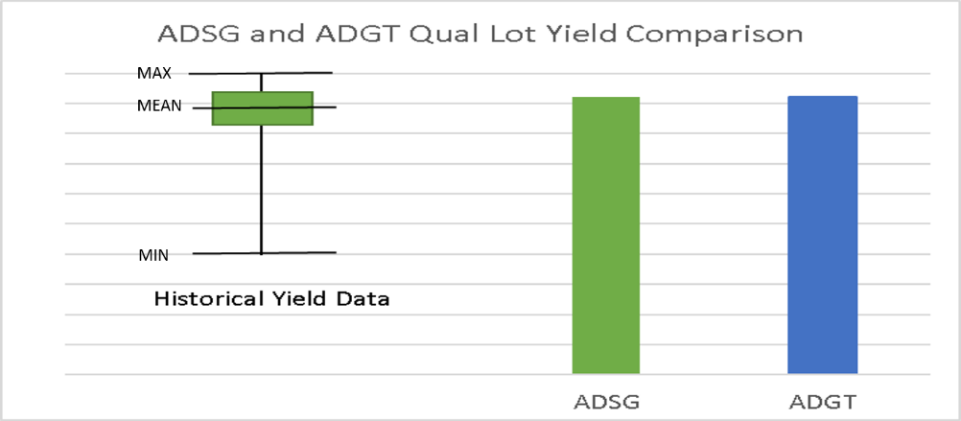

To ensure QA Program does not trim untrimmed/fresh parts, samples of untrimmed or fresh parts were tested using QA Program. LT3795 has no trimming on final test, criteria not applicable

To gather test performance data to allow estimation of the overall test repeatability and reproducibility from the production test solution, GR&R was performed on 10 serialized units tested on 1 test board and 3 test systems. GR&R result was analyzed and summarized in Table 6.
Table 6: GR&R Result
Generic | Package | Lot Number | No. of Units | No. of Test Boards | No. of Testers | All parameters passed R&R % =<10%?
LT3795 | 28-LEAD PLASTIC TSSOP | 993984.1 | 10 | 1 | 3 | Yes – ALL PASSED

APPROVALS:
Technical Review Board No. 60579 - ADSG to ADGT Test Transfer

ADDITIONAL INFORMATION:
Homepage: https://www.analog.com/en/index.html
Customer Service: https://www.analog.com/en/support/technical-support.html

